02.00 PARTNER SIGN-OFF

The following describes the functionality and features included in Probe Audit Premium+

Objective

The objective of this document is to provide the engagement partner with a consolidated summary of the audit engagement, including risk assessments at financial statement and assertion level, work program progress and conclusions for each significant class of transactions, account balance and disclosure (SCOTABD), fraud risk responses, and the engagement partner declaration, enabling the partner to review and sign off on the engagement prior to dating the auditor’s report.

The following key concepts of the Probe Audit Premium+ Methodology are set in this document:
- Engagement partner’s overall responsibility for audit quality (ISA 220)
- Evaluation of risk assessments, conclusions, and audit opinion at financial statement level
- Final sign-off that authorises the release of the audit report

Document placement

Document 02.00 – Partner sign-off can be found in the Finalisation folder in the Caseware document manager.
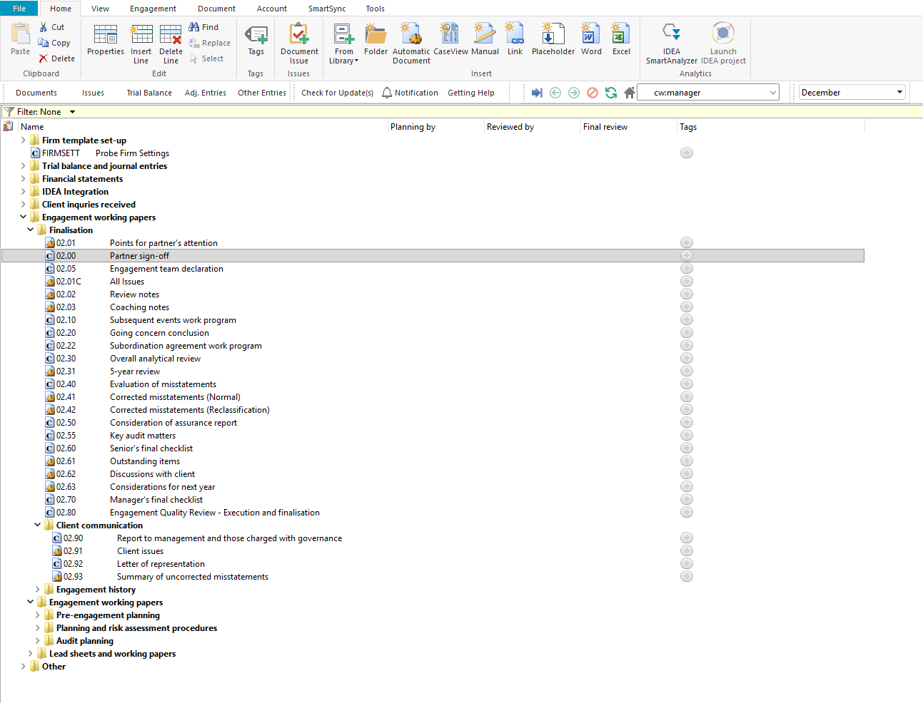

Document content

This document is designed to be a CaseView summary document that consolidates key audit information from across the engagement file for the engagement partner’s review and sign-off. The document auto-populates risk assessments, work program progress, and conclusions from the relevant working papers in the engagement file. The engagement partner is required to review all sections and provide input where indicated, including partner comments, the engagement partner declaration, and the final sign-off.

This document addresses the requirements of ISA 220 (Quality Management for an Audit of Financial Statements), ISA 240 (The Auditor’s Responsibilities Relating to Fraud in an Audit of Financial Statements), and ISA 700 (Forming an Opinion and Reporting on Financial Statements).

This document is divided into different bookmarks in the document map to assist you in reviewing and signing off on the audit engagement:

Summary at financial statement level

Fraud risk

Work program sign-off sections (Accounting records, Opening balances and comparatives, Financial statement preparation, Laws and regulations)

Summary at assertion level (per SCOTABD)

Engagement partner declaration

Partner sign-off

Engagement partner
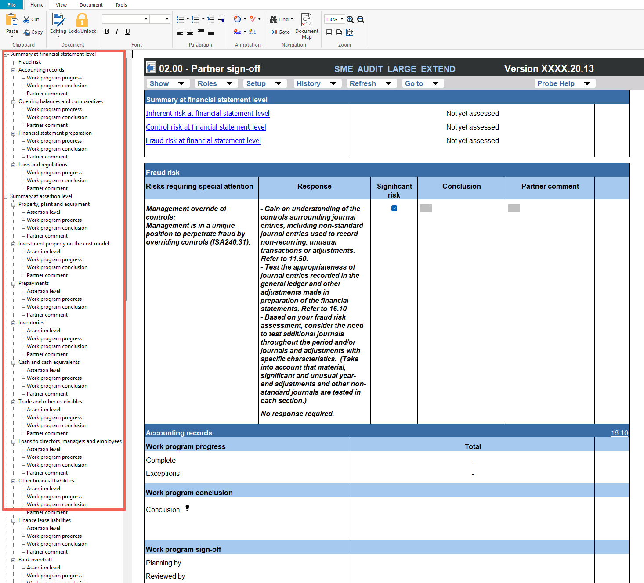

Layout
Column | Input Required | Outcome
Summary at financial statement level
Inherent risk at financial statement level | No input required. Auto-populated from 11.20 – Inherent risk assessment. | No impact on the engagement file. Displays the assessed inherent risk at financial statement level for the partner’s review.
Control risk at financial statement level | No input required. Auto-populated from 11.30 – Evaluation of system of internal control. | No impact on the engagement file. Displays the assessed control risk at financial statement level for the partner’s review.
Fraud risk at financial statement level | No input required. Auto-populated from 11.25 – Fraud risk assessment. | No impact on the engagement file. Displays the assessed fraud risk at financial statement level for the partner’s review.
Fraud risk
Risks requiring special attention | No input required. Auto-populated from the fraud risk assessment. Displays fraud risks requiring special attention, including management override of controls (ISA 240.31) and fraud in revenue recognition (ISA 240.26) per revenue stream. | No impact on the engagement file. Displays the fraud risks for the partner’s review.
Response | No input required. The response to each identified fraud risk is auto-populated from the relevant working papers. | No impact on the engagement file. Displays the audit response to the fraud risk for the partner’s review.
Significant risk | No input required. Indicates whether the fraud risk has been identified as a significant risk. | No impact on the engagement file.
Conclusion | No input required. The conclusion on each fraud risk is auto-populated from the relevant working papers. | No impact on the engagement file.
Partner comment | Enter any comments or observations relating to the fraud risk section. | No impact on the engagement file. Documents the partner’s comments for the engagement file.
Work program sign-off sections
Work program progress | No input required. The work program progress (Complete and Exceptions totals) is auto-populated from the relevant work program for each section: Accounting records (16.10), Opening balances and comparatives (17.10), Financial statement preparation (18.10), and Laws and regulations (20.10). | No impact on the engagement file. Displays completion status for the partner’s review.
Work program conclusion | No input required. The conclusion is auto-populated from the relevant work program. | No impact on the engagement file. Displays the work program conclusion for the partner’s review.
Work program sign-off | No input required. The sign-off details (Planning by, Reviewed by, Performed by, Final review) are auto-populated from the relevant work program. | No impact on the engagement file. Displays the sign-off status for the partner’s review.
Partner comment | Enter any comments or observations relating to the work program section. | No impact on the engagement file. Documents the partner’s comments for the engagement file.
Summary at assertion level (per SCOTABD)
Assertion level | No input required. For each SCOTABD, the assertion level data is auto-populated and displays the inherent risk assessment and risk of material misstatement across the assertions: Completeness (C), Existence/Occurrence (EO), Rights and Obligations (RO), Accuracy, Valuation and Allocation (AVA), Cut-off (CO), and Presentation and Disclosure (PD). | No impact on the engagement file. Displays the risk assessment per assertion for the partner’s review.
Assertion selected for testing | No input required. Displays which assertions have been selected for testing per SCOTABD, as determined in the audit plan. | No impact on the engagement file.
Work program progress | No input required. The work program progress per assertion (Complete and Exceptions) is auto-populated from the relevant SCOTABD work program. | No impact on the engagement file. Displays completion status per assertion for the partner’s review.
Work program conclusion | No input required. Displays the estimated audit risk remaining, desired audit risk, and conclusion per SCOTABD, auto-populated from the relevant work program. | No impact on the engagement file. Displays the audit conclusion per SCOTABD for the partner’s review.
Work program sign-off | No input required. The sign-off details are auto-populated from the relevant SCOTABD work program. | No impact on the engagement file. Displays the sign-off status per SCOTABD for the partner’s review.
Partner comment | Enter any comments or observations relating to the SCOTABD section. | No impact on the engagement file. Documents the partner’s comments per SCOTABD for the engagement file.
Engagement partner declaration
Questions | No input is required in this column. Displays 16 questions addressing the engagement partner’s responsibilities under ISA 220, including ethical requirements, consultations, differences of opinions, audit documentation, significant judgments, audit evidence, financial statement review, key audit matters, communications, and the EQR process. | No impact on the engagement file. Provides the declaration framework for the partner’s review.
Ref. | Enter a cross-reference to the relevant working paper or supporting documentation for each declaration question. | No impact on the engagement file. Documents the cross-reference for the engagement file.
Detail | Enter a description or further detail in support of your response to each declaration question. | No impact on the engagement file. Documents the partner’s detail for the engagement file.
Yes / No | Select ‘Yes’ or ‘No’ to respond to each declaration question. | No impact on the engagement file. Records the partner’s declaration response for the engagement file.
Partner sign-off
Firm mandatory – based on events and conditions present | Select the tick box if a firm mandatory condition is present based on events and conditions identified during the engagement. Complete the Ref., Detail, and Yes/No columns as applicable. | No impact on the engagement file. Documents any firm mandatory conditions for the engagement file.
Engagement partner
Comment | Enter any overall comments relating to the engagement. | No impact on the engagement file. Documents the partner’s overall comment for the engagement file.
Name | Enter the name of the engagement partner. | No impact on the engagement file. Records the engagement partner’s name for the engagement file.
Signature | Enter or apply the engagement partner’s signature. | No impact on the engagement file. Records the engagement partner’s signature for the engagement file.
Date | Enter the date of the partner sign-off. | No impact on the engagement file. Records the date of the partner’s sign-off for the engagement file.

Document outcomes

The engagement partner must review the consolidated summary of risk assessments at financial statement and assertion level, work program progress and conclusions, and fraud risk responses to satisfy themselves that the audit has been performed in accordance with the Probe Audit Premium+ Methodology and applicable ISAs.

The engagement partner must complete the engagement partner declaration by responding to all 16 questions with ‘Yes’ or ‘No’, providing references and detail where applicable. These questions address the partner’s responsibilities under ISA 220, including ethical requirements, consultations, differences of opinions, audit documentation review, significant judgments, audit evidence, financial statement review, key audit matters, communications, and the engagement quality review process.

The engagement partner must complete the final sign-off by entering their comment, name, signature, and date, confirming that they have been sufficiently and appropriately involved throughout the audit engagement and that the significant judgments made and conclusions reached are appropriate.

Group Audits

When the engagement type was selected as ‘Group Audit Single’ or ‘Group Audit Multiple’, the partner sign-off document will include additional SCOTABD sections and group-specific information relevant to the group audit engagement file. The engagement partner must review the consolidated summary for all components and ensure that sufficient appropriate audit evidence has been obtained to provide a basis for forming an opinion on the group financial statements.

IN CONCLUSION

Features

The following features are available in the document:

Insert or delete a comment, see page F3

Guidance, see page F16

Freeze, see page F19

